**Cowrywise Data Analysis Assessment Summary**

**Objective:**  
The primary goal was to carry out data analysis using SQL Server Management Studio (SSMS). This involved migrating and transforming data from a MySQL environment into SQL Server, utilizing tools like Docker, PowerShell, and SQL Server Migration Assistant (SSMA).

### **Tools Used**

**Docker** – To set up and manage a MySQL database in a containerized environment.

**PowerShell** – For automating the execution and management of Docker containers.

**SQL Server Migration Assistant (SSMA)** – To facilitate schema conversion and data migration from MySQL to SQL Server.

**SQL Server Management Studio (SSMS)** – For executing SQL queries and conducting data analysis after successful migration.

**Overview of the Process**

1. **Setting Up the MySQL Environment Using Docker**  
   I initiated the process by deploying a Docker container configured to run MySQL. This provided a stable and self-contained environment for hosting the source database. 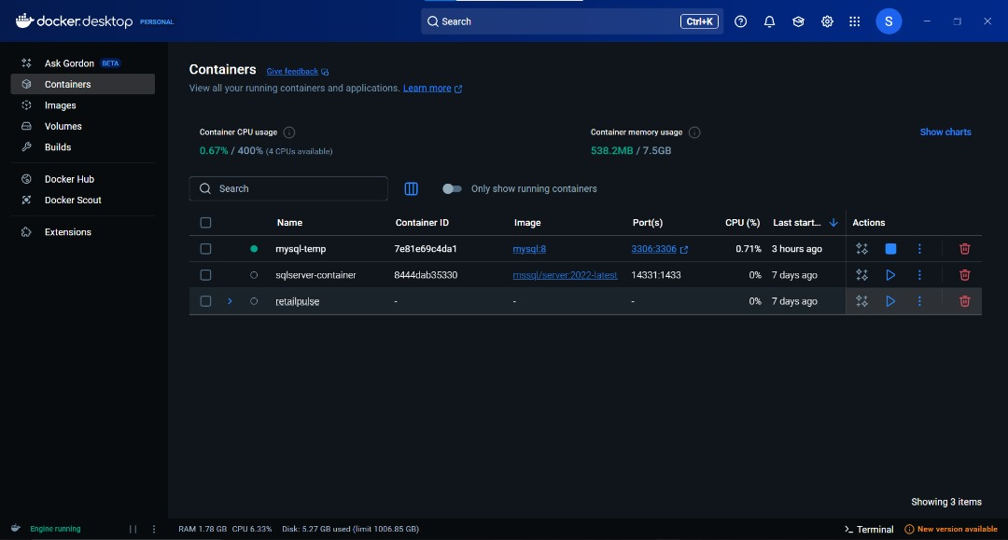
2. **Managing the Container via PowerShell**  
   Using PowerShell scripts, I started and managed the Docker container to ensure the MySQL instance was active and accessible for data migration. 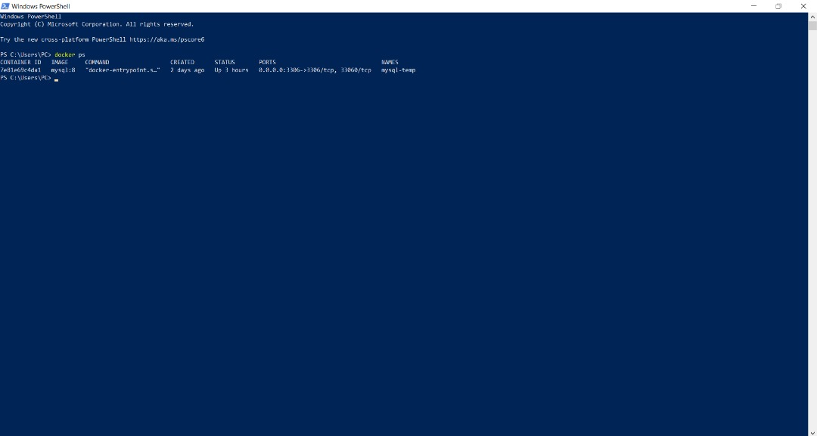
3. **Schema Conversion Using SSMA**  
   I connected directly to the MySQL container using SSMA.
   * The MySQL schema was then converted into a format compatible with SQL Server.
   * After the conversion, the updated schema was synchronized with the target SQL Server database. 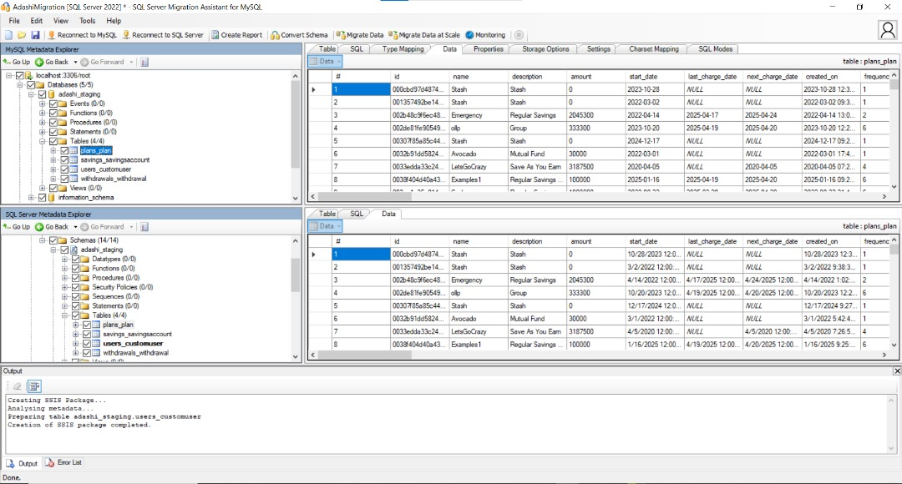
4. **Data Transfer Phase**  
   Once the schemas were aligned, I proceeded to migrate the actual dataset from MySQL to SQL Server using SSMA as the main tool.
5. **Resolving Import Errors**  
   During the migration, an issue occurred with the **user_customer** table, which failed to transfer correctly.
   * As a workaround, I exported this table into a CSV flat file from MySQL.
   * Then, I used the Import Flat File Wizard in SSMS to successfully load the data into SQL Server.
6. **Performing Analysis in SSMS**  
   After all tables were migrated, I used SSMS to run various SQL queries for data exploration and analysis.  
   This included tasks such as:
   * Filtering and aggregating data
   * Joining multiple tables
   * Extracting meaningful insights from Cowrywise's dataset

**Key Questions Analyzed:**

1. **Identifying high-value customers with multiple products**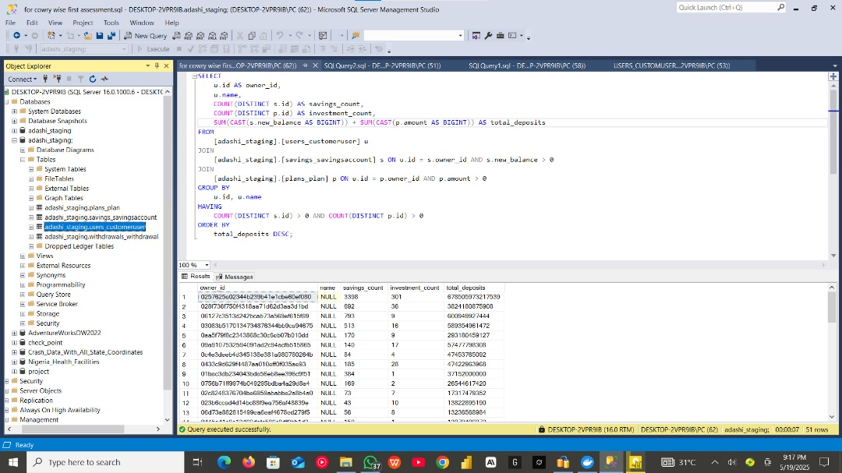
2. **Analyzing transaction frequency patterns**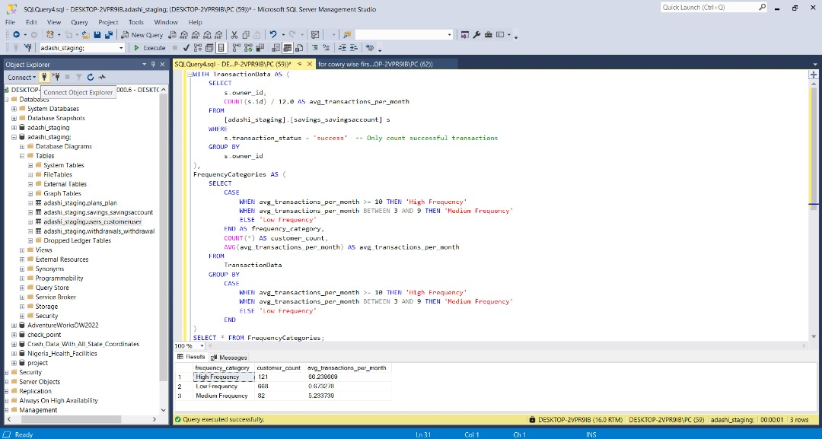
3. **Detecting potentially inactive accounts**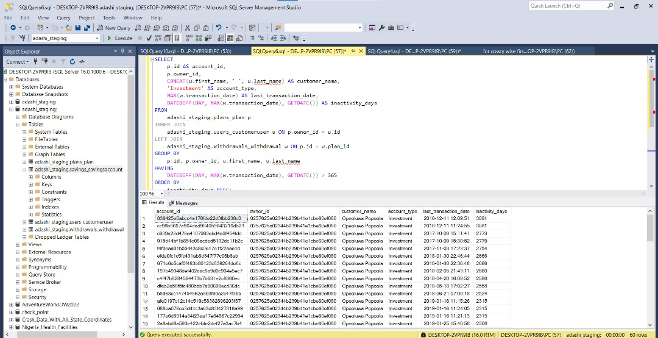

**Conclusion:**  
This project provided hands-on experience in database migration across different platforms, troubleshooting real-world import issues, and leveraging SQL for insightful analysis. It also enhanced my understanding of containerization and automation using Docker and PowerShell, along with improving my problem-solving capabilities within a structured data workflow.